|  |  |  |  |  |  |
| --- | --- | --- | --- | --- | --- |
|  | 1,2  8.00AM – 10.00AM | 3,4  10.00AM-  12.00PM | 5,6  13.00PM-  15.00PM | 7,8  15.00PM- 17.00PM |  |
| Monday | 1 |  | 2 | 3 |  |
| Tuesday | 3 | 2 |  | 1 |  |
| Wednesday | 4 |  | 1 | 3 |  |
| Thursday | 4 | 1 | 3 |  |  |
| Friday |  | 2 | 4 | 3 |  |

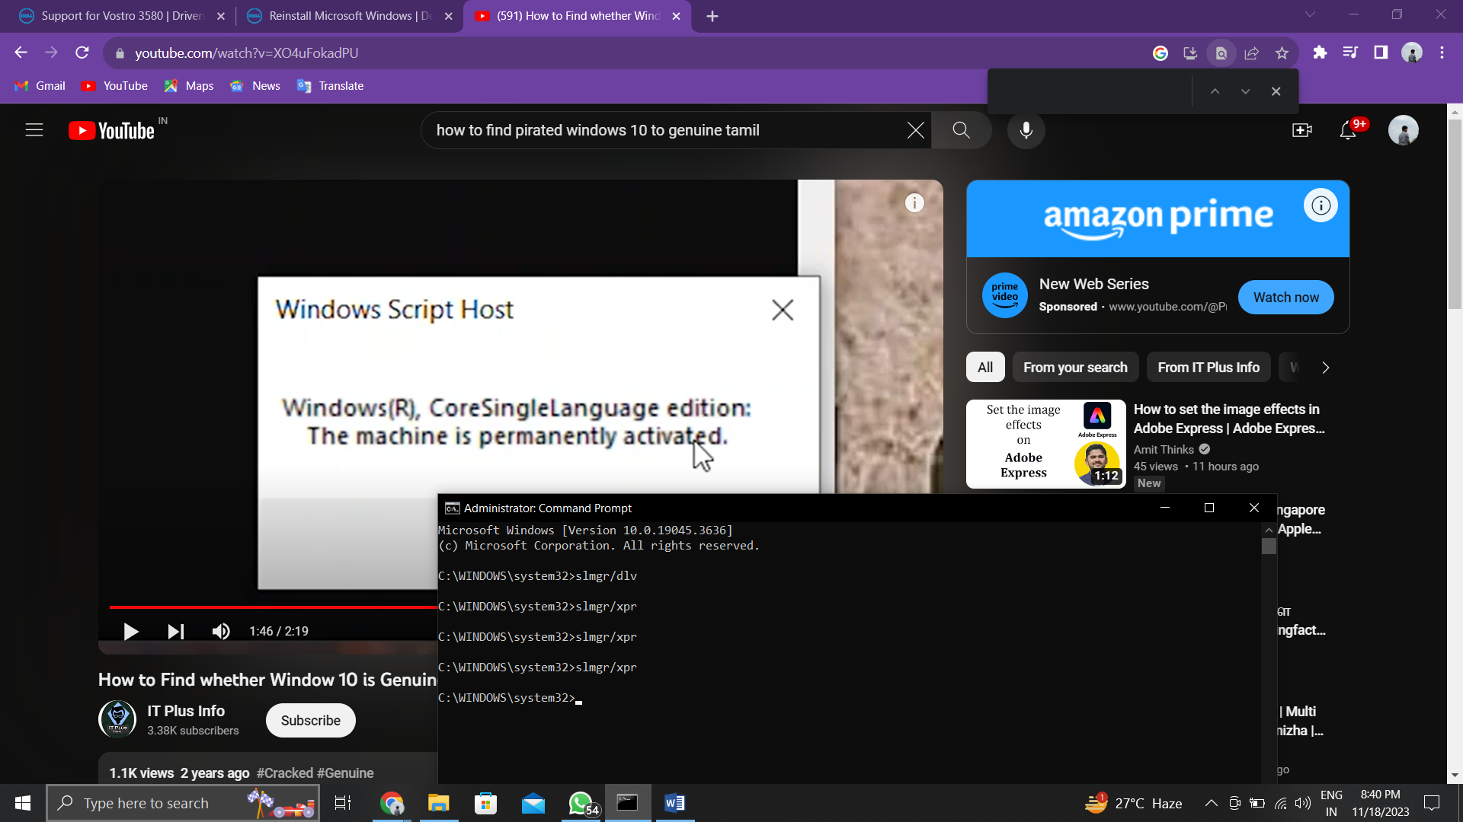slmgr/xpr

